**Student: Gleb Kiva**

**Quiz 2**

1. **Complete the second sentence so that it means the same as the first.**

1 I'm almost sure you left your phone in the restaurant.

You probably left your phone in the restaurant.

2 It was wrong of you not to tell me you'd borrowed my car.

You could tell me you'd borrowed my car.

3 It's possible that the backpackers got lost.

The backpackers might get lost.

4 I'm sure it wasn't Jake's fault. He wasn't there last night.

It surely wasn’t Jake's fault. He wasn't there last night.

5 I think somebody has tried to break in.

It looks like somebody has tried to break in.

6 This meat has a very similar taste to beef.

This meat tasted almost the same as beef.

7 I don't like cooking fish because then there's an awful smell in the kitchen.

I don't like cooking fish because then the kitchen smells awfully.

1. Tick (✓) A, B, or C to complete the sentences.

1 I wish my flatmates wouldn’t ________ all the time!

A discuss      B argue   X   C deny

2 I’ve used the gym twice and it ________ really good.

A seems   X   B looks      C notices

3 What time should we ________ the next train to arrive?

A wait      B notice      C expect  X

4 According to research, a healthy lifestyle can ________ some illnesses.

A prevent   X   B avoid      C expect

5 He ________ a bank in that film, but of course, he’s a good guy really.

A robs   X   B thieves      C steals

6 Calum ________ that he’d broken the window.

A refused      B argued      C denied   X

7 Unless they ________ his salary, he’s going to look for another job.

A rise   X   B raise      C higher

8 ________ me to email Sandrine. I need to give her directions to our flat.

A Remember      B Notice      C Remind   X

9 I ________ you would stop tapping your fingers on the table!

A hope      B expect      C wish   X

10 Is it OK if I ________ your dictionary for a minute?

A rob      B borrow   X   C lend

1. **Look at the picture and write the parts of the body. Write 3-5 more parts of the body or internal organs that aren’t in the picture.**

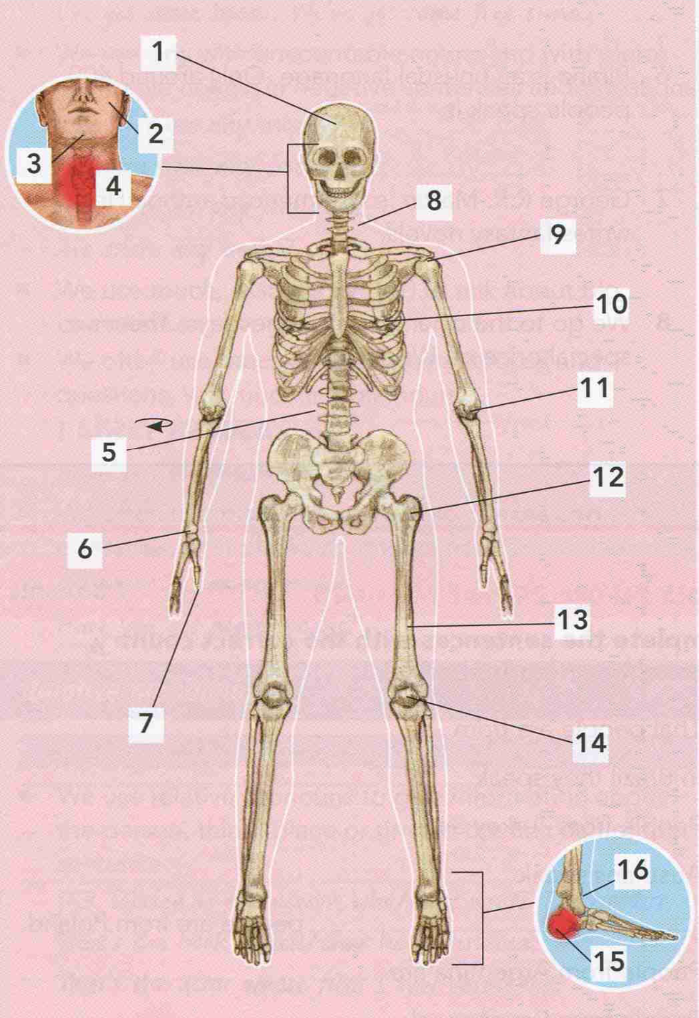

1. Skull
2. Nostrils
3. Chin
5. Spine
6. Wrist
7. Finger /thumb
8. Neck
9. Shoulder
10. Lung


14. Ankle
15. Toes
16. Feet
17. **Complete the sentences with missing verbs.**
18. I used to break my thumb at school when I was little until the teacher stopped me.
19. My dad raised his eyebrows when I said I was going to another party.
20. I’m not very fit or flexible. I certainly can’t touch my toes.
21. You need to break this steak for a while – it’s pretty tough.
22. I couldn’t stop staring at that woman’s hat – it was so bizarre!
23. The woman we asked for directions ____________ her shoulders and said she couldn’t help.
24. Try not to sleep during the lesson – it’s rude! Go home and get some sleep.
25. He talked at me to show that he was only joking.
26. She grabbed a tissue and loudly scrabbed? her nose.
27. Don't ignore the mosquito bite. You'll only make it worse.